**Smart City**

Sustainable Smart City Assistant Using IBM Granite LLM

**Team Leader:** Tamilarasan S

**Team members :** 1.Ranjithkumar K 2.Siva B 3.Surya S

**Introduction:**

A sustainable Smart City assistant built using IBM’s Granite LLM is an advanced AI-powered platform designed to help urban communities become more efficient, eco-friendly, and citizen-centric. By leveraging Granite’s large language model capabilities, the assistant can process vast amounts of city data in real time, provide actionable insights for energy and water conservation, optimize public transportation, and support urban planning decisions. It enables city administrators and residents to interact naturally through conversational AI, making sustainability initiatives more transparent, efficient, and accessible to all.

**Project Description:**

Sustainable Smart City Assistant uses the Granite model from Hugging Face to help with city sustainability, governance, and citizen engagement. It includes quick tools for a City Health Dashboard, citizen feedback, document summaries and eco tips. This project will be deployed in Google Colab using Granite for easy setup and smooth performance.

A Sustainable Smart City Assistant leveraging the IBM Granite Large Language Model (LLM) involves developing an AI-powered system designed to provide information and insights related to sustainable urban development and smart city initiatives.

Key components and functionalities of such an assistant often include:

**LLM Integration:**

The core of the assistant relies on the IBM Granite LLM, which processes natural language queries and generates relevant responses. This includes understanding questions about various aspects of smart cities and sustainability, such as urban planning, energy management, waste reduction, and transport solutions.

**Data Sources:**

The assistant can integrate with diverse data sources, including databases containing information on city development, APIs providing real-time data on city services, and documents related to sustainable practices and regulations.

**Multi-Agent Architecture:**

Advanced implementations may employ a multi-agent LLM system, where different agents specialize in tasks like question routing, context extraction from various sources, and synthesizing final answers. This allows for more complex query handling and information gretrieval.

**Application Interface:**

The assistant typically interacts with users through a user-friendly interface, such as a web application chatbot, enabling easy access to information and a conversational experience.

**Sustainability Focus:**

The assistant's primary goal is to promote awareness and provide solutions for sustainable urban living. This includes offering insights on topics like smart energy grids, renewable energy integration, efficient waste management, and sustainable transportation options.

**Tools and Technologies:**

Development of such an assistant often involves various tools and technologies, including Python for programming, FastAPI for building APIs, Streamlit for creating web applications, and leveraging platforms like IBM watsonx.ai for LLM deployment and management.

**Content Moderation:**

To ensure responsible AI use, content moderation mechanisms like IBM Granite Guardian can be integrated to filter out unsafe or inappropriate responses and ensure the information provided is reliable and aligned with ethical guidelines.

**Improved Decision Support:**

The integration of LLM agents, particularly with Retrieval-Augmented Generation (RAG) technology, significantly improves the accuracy and relevance of responses to complex urban queries, leading to better-informed decision-making in areas like strategic development and service accessibility.

**Enhanced Urban Planning and Management:**

By processing and analyzing vast amounts of urban data, the assistant can provide insights for optimizing city services, infrastructure development, and resource management, ultimately contributing to more efficient and sustainable urban environments.

**Facilitation of Citizen Engagement:**

The assistant can act as an intelligent interface for citizens, enabling them to access information, provide feedback, and participate in urban development processes more effectively.

**Addressing Urban Challenges:**

The application of AI, particularly LLMs like IBM Granite, offers a powerful tool to address multifaceted challenges faced by rapidly urbanizing areas, including traffic congestion, environmental degradation, and equitable resource distribution.

**Promoting Sustainability Goals:**

By enabling data-driven insights and supporting the implementation of sustainable practices in areas like energy management, waste reduction, and green infrastructure, the assistant contributes directly to achieving urban sustainability targets

Output:

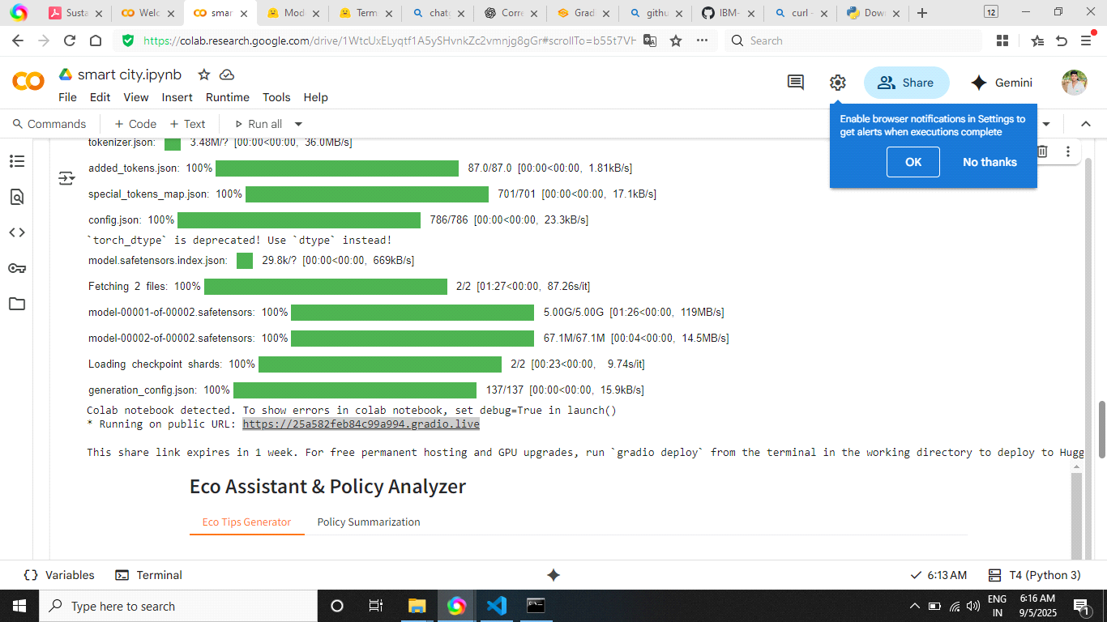

Coding:

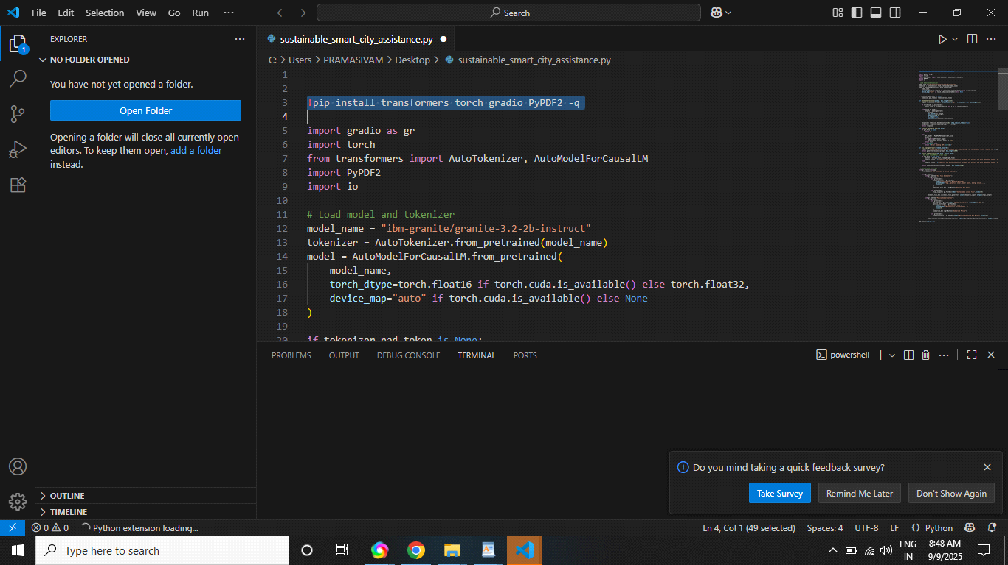

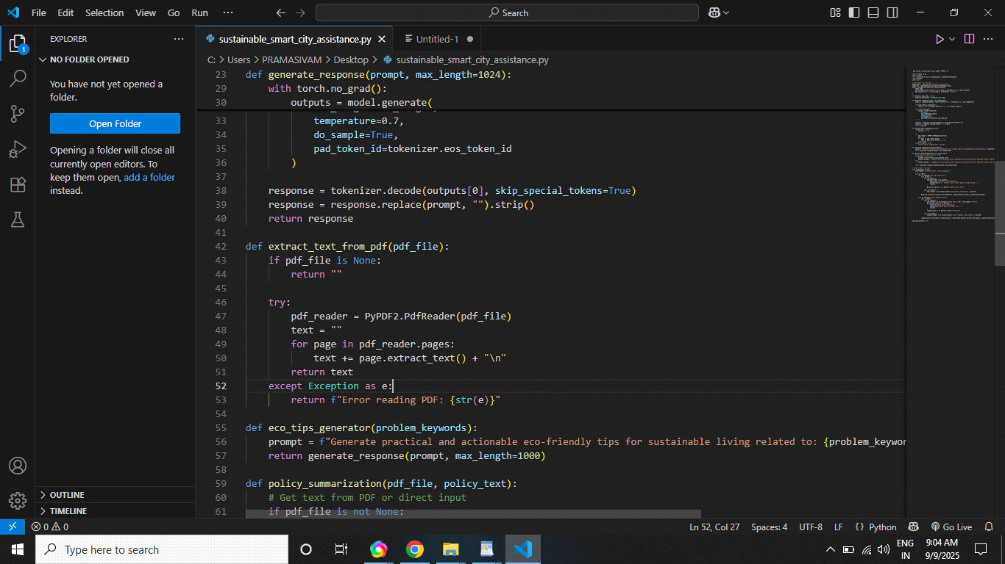

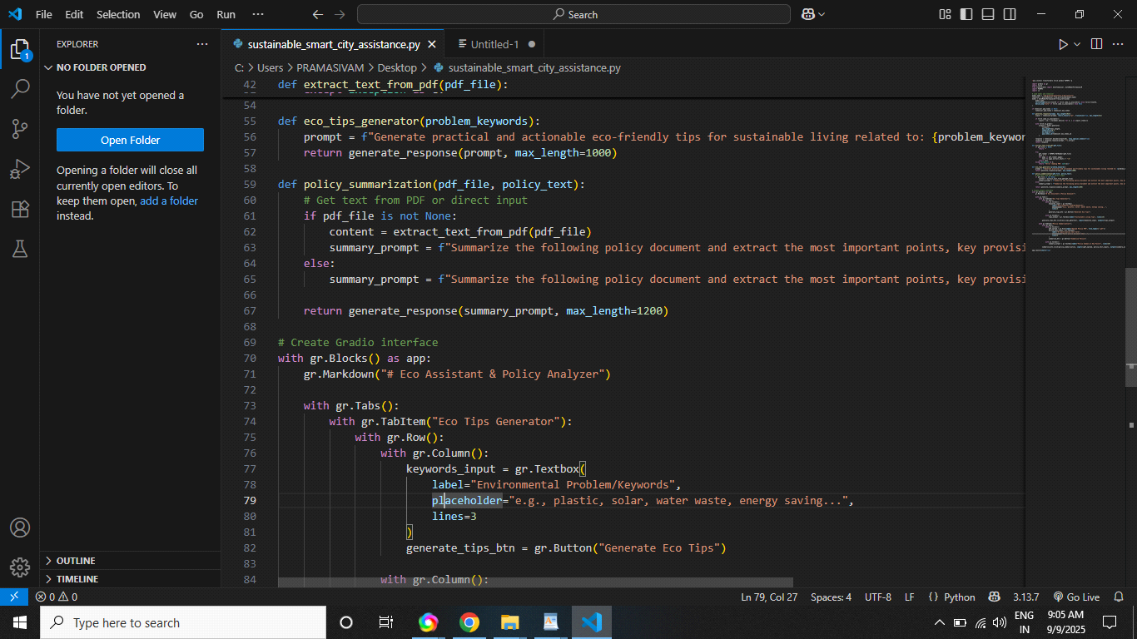

**Conclusion:**

The development of a Sustainable Smart City Assistant leveraging the IBM Granite LLM demonstrates a significant advancement in urban management and decision-making. This approach integrates large language models with urban data and systems to enhance sustainability and resilience within cities.